|  |  |
| --- | --- |
| 1 December 2022 | SWP Ref: 2207396  SWP-SIR- 2207396 Rev.A |

Advanced Buildings and Restorations  
C/- Craig Wilshaw

PO Box 717

North Lakes QLD 4509

**Building/Engineering Report**

**Insured:** CTS 25838

**Address:** 23 Vauxhall Street, Virginia QLD 4014

**Builder:** Advanced Buildings and Restorations

**Builder Ref No:** 38846

**Site Inspection: 21 November 2022 – 10:30am**

Thank you for your instruction dated 15 November 2022 to inspect and provide a report on our findings at the above address; specifically, you have requested that we report on the following:

***“Allowance for Engineer Inspection to confirm if superficial damages only.”***

# Overview

The property in question is a two-storey precast concrete constructed commercial property supporting a corrugated metal sheeted roof. **Image 1**

From the provided advice, the subject property sustained vehicle impact damage to the concrete slab in the South-Western corner about the driveway, 2 to 3 months ago.

For referencing purposes, an aerial site plan of the subject property in the orientation of True North has been provided in **Figure 1**.

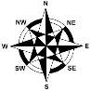 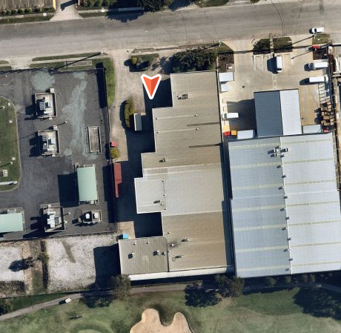

Area of Impact

Figure 1 – Aerial Site Plan of Subject Property

As instructed, *Silver Wolf Projects* ***(SWP)*** inspected the subject property to assess the extent of damage sustained by the subject property as a result of vehicle impact to the concrete slab.

# Observation, Comments and Discussion

*Photos Attached as Appendix*

Inspection was undertaken at the subject property in the presence of the Insured to which the following was noted:

1. In schematically illustrating the location of impact about the subject property, we provide **Figure 2** below:

Area of impact

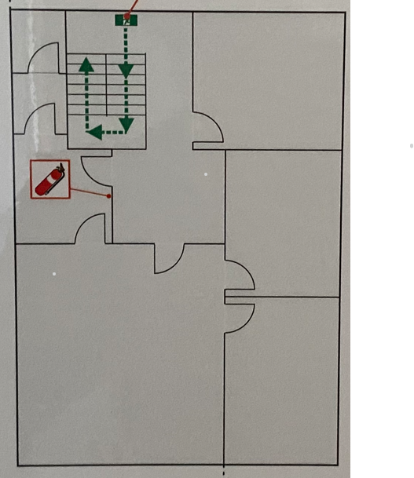

Room 2

Room 1

Room 3

Figure 2 - Schematic First Floor Plan of Subject Property

## External Damage

### Images 2 - 9

1. We noted cracking and chipping of concrete slab in the corner of the South-Western face of the building about the driveway, consistent with the vehicle impact event. **Images 2 – 9**
2. We did not identify any excessive movement, cracking and damage from the vehicle impact to the adjacent external areas.
3. We noted pre-existing hairline cracking about the concrete slab unrelated to the impact.
4. In our opinion, the observed cracking is insignificant to compromise the structural integrity of the property.
5. As such, we opine that, the observed cracking can be repaired and is not structurally demeaning to the subject property.

## Internal Damage

### Images 10 - 32

1. In addition to the internal areas at the adjacent corner location of the vehicle impact, we inspected office rooms 2 and 3 about the Western elevation of the subject property.
2. From our observation, we noted pre-existing hairline cracking and evident patch repair in the Room 1 adjacent to the impacted external area. **Images 14 - 16**
3. We consider the damage and cracking consistent with long term and ongoing general building movement.
4. We further noted, pre-existing issues of moisture permeation within the internal areas. **Images 20 - 21**
5. Similarly, we noted cracking on the corner of the wall propagating from the window about the Office Room 2 and 3 at the other side of the sustained vehicle impact.
6. We opine that, these areas are locations of high stress concentrations and are susceptible to cracking from general building and thermal movement over time and age-related wear & tear/ deterioration.
7. Having said that, no signs of excessive movement, distress and cracking were noted about the internal areas to suggest that the damage occurred due to vehicle impact.
8. In our opinion, if such vehicle force did not cause damage to the direct corresponding room, then it is absolutely unlikely that any transfer of force caused any movement or cracking to the adjoining areas.
9. As such, we consider that the vehicle impact force was minimal in both significance and magnitude to cause internal damage to the corresponding rooms internal fit-out.
10. On the above basis, on-going and cyclic foundation reactivity causes ground movement and settlement to occur and ultimately result in the experienced building movement as observed in the internal areas.
11. Noting the above, we confirm the cause of the observed cracking damage to the internal areas and external areas except for the localized area of the above-mentioned vehicle impact is attributable to long-term general building movement due to thermal contraction/ expansion and inherent maintenance issues within the subject property and is unrelated to the vehicle impact event.
12. As such, we opine that the cracking and chipping of concrete due to the vehicle impact is superficial, localized to the external area only and has not impacted internal areas and is not structurally demeaning to the subject property.

# Conclusion

***Confirm if superficial damages only***

From the observation and assessment of the subject property, we opine that the structural integrity of the concrete slab and the adjacent areas (internally and externally) has not been compromised due to the occurred vehicle impact.

**To this end, we opine that the damage sustained by the concrete slab due to vehicle impact is superficial and is not structural demeaning to the subject property.**

# Recommendations

In providing recommendations for repair on a “*without prejudice*” basis, we advise the following actions should be considered:

### Reinstatement works

1. Reinstate the chipped concrete slab using high strength cementitious mortar in accordance with the manufacturer’s specification to match existing finish. **Approximately 1.0 m2.**
2. Allow for the preparation and application of three (3) coats of external acrylic paint to the affected area to match existing colour. 1 off - **Approximately 1.0 m2**

# Qualification on any Reference Made to Current NCC BCA 2019, Australian Standards and/or Guidelines within the Report

We advise that any reference made to current NCC Building Code of Australia (BCA) 2019, Australian Standards and/or guidelines has ONLY been made to clarify and explain the mechanism of damage/occurrence unless clearly stated otherwise.

Such reference to current NCC BCA 2019, Australian Standards and/or guidelines is not for the purpose of compliance and/or conjecture about building/design/construction/workmanship defects unless clearly stated otherwise.

The Building Code of Australia (BCA) has developed and issued for the firsts time in 1988; however, this version of BCA was not adopted by any of the States and Territories up until the BCA 1990 version which was adopted at various dates by each States and Territories namely, ACT on 5/11/90, NSW on 1/1/92, NT on 18/12/91, QLD on 1/1/92, SA on 17/6/91, TAS on 2/11/94, on VIC on 8/4/91 and WA on 28/7/89.

In cases where the age of building and construction predates the above-mentioned adoption dates of BCA, we advise any reference made to BCA should not be used for assessment of either design, construction and/or workmanship defects.

# Closure

We confirm our report has been prepared in an objective and independent manner as a professional and Chartered Engineering and Licenced Building Firm subject to reference and application of qualified engineering method, factual and evidence-based assessment without prejudice.

We advise that our site inspection has only completed in areas where pertains to your instructions or requests/issues raised during inspection onsite. We confirm areas not included within this report was not subject of the instructions and/or safe access to the areas of concern was not available despite our reasonable attempts to undertake the inspection in those areas.

Our method of visual and non-destructive inspection, assessment and reporting has been completed with reference to the National Building Code of Australia (NCC BCA 2019), relevant Australian Standards, manufacture’s specifications and/or relevant state Guide to Standards and Tolerances where applicable.

We trust this meets your requirements and should you require further information or clarification on the matter, please do not hesitate to contact the undersigned.

Yours Faithfully,

**Silver Wolf Projects Pty Ltd**

|  |  |  |  |  |  |  |
| --- | --- | --- | --- | --- | --- | --- |
| Inspected by: | Prepared by: | Reviewed by: | Approved by: |  |  |  |
| Naser Mahan  Structural/Civil Engineer  B.E (Civil)   | Pranisha Lamichhane  Structural/Civil Engineer  B.E (Civil)   | Nik Housh  Associate Structural/Civil Engineer  B.E (Civil) M.Eng (Structural)  MIE Aust. CPEng NER 4261785  NSW PRE 1053 (Civil/Structural)  RPEQ 17145  C:\Users\Nick\Google Drive\Legal Docs\SIGNATURE.jpg | Deniz Bekir  Principal Engineer/Building Consultant  B.E. (Civil)(Hons) Certificate IV Building Studies  MIE Aust. CPEng NER 2066978  NSW PRE 995 (Civil/Structural)  RPEQ 12771  VIC PE 001961  NSW Building Contractors Lic No. 161767C  ACT Contractors Lic No. 20201215  QBCC Contractors Lic No. 15213813  VBA Building Lic No. DB-U 72448  A picture containing chart  Description automatically generated |  |  |  |

# Images

|  |
| --- |
|  |
| **Image**  View of the subject property |

|  |
| --- |
|  |
| **Image**  View of the damage to the subject property as a result of vehicle impact |

|  |
| --- |
|  |
| **Image**  View of the damage to the subject property as a result of vehicle impact |

|  |
| --- |
|  |
| **Image**  View of the damage to the subject property as a result of vehicle impact |

|  |
| --- |
|  |
| **Image**  View of the damage to the subject property as a result of vehicle impact |

|  |
| --- |
|  |
| **Image**  View of the damage to the subject property as a result of vehicle impact |

|  |
| --- |
|  |
| **Image**  View of the subject property |

|  |
| --- |
|  |
| **Image**  View of the pre-existing hairline cracks about the concrete slab |

|  |
| --- |
|  |
| **Image**  View of the damage to the subject property as a result of vehicle impact |

|  |
| --- |
|  |
| **Image**  View of the internal areas |

|  |
| --- |
|  |
| **Image**  View of the internal areas adjacent to external vehicle impact |

|  |
| --- |
|  |
| **Image**  View of the internal areas adjacent to external vehicle impact |

|  |
| --- |
|  |
| **Image**  View of the internal areas adjacent to external vehicle impact |

|  |
| --- |
|  |
| **Image**  View of evident pre-existing patch repair and hairline cracking on the wall about the room adjacent to the vehicle impact |

|  |
| --- |
|  |
| **Image**  View of the evident pre-existing patch repair and hairline cracking on the wall about the room adjacent to the vehicle impact |

|  |
| --- |
|  |
| **Image**  View of the hairline cracking on the wall propagating from the window measuring about 0.2mm |

|  |
| --- |
|  |
| **Image**  View of ceiling lining and concrete wall junction adjacent to external vehicle impact |

|  |
| --- |
|  |
| **Image**  View of concrete wall junction adjacent to external vehicle impact with evident corrosion on the floor |

|  |
| --- |
|  |
| **Image**  View of the ceiling lining and wall adjacent to external vehicle impact |

|  |
| --- |
|  |
| **Image**  View of the evident moisture permeation from the ceiling lining |
|  |
| **Image**  View of the evident moisture permeation from the window |

|  |
| --- |
|  |
| **Image**  View of the internal areas adjacent to external vehicle impact |

|  |
| --- |
|  |
| **Image**  View of the window opening showing no signs of cracking or distress |

|  |
| --- |
|  |
| **Image**  View of the corner junction of wall about Room 3 |

|  |
| --- |
|  |
| **Image**  View of the corner junction of wall about Room 3 |

|  |
| --- |
|  |
| **Image**  View of the ceiling lining about Room 3 |

|  |
| --- |
|  |
| **Image**  View of the hairline cracking propagating from the window |

|  |
| --- |
|  |
| **Image**  View of the cracking on wall propagating from the window |

|  |
| --- |
|  |
| **Image**  View of the hairline cracking propagating from the window |

|  |
| --- |
|  |
| **Image**  View of the Room 2 |

|  |
| --- |
|  |
| **Image**  View of the hairline cracking on the wall |

|  |
| --- |
|  |
| **Image**  View of hairline cracking propagating from the window |